**]GENETICS AND EVOLUTION EXAM REVISION SOLUTIONS9**

|  |  |
| --- | --- |
| DNA | Code for how to make proteins |
| gene | Strand of DNA that code for a characteristic. |
| allele | Alternative code for a gene. |
| chromosome | Linear collection of genes |
| diploid | Total number of chromosomes in the nucleus. |
| haploid | Half the number of chromosomes in sex cells. |
| interphase | Non- dividing phase of cell cycle. |
| DNA replication | Making an identical copy of DNA |
| centriole | Spindle formation in animal cells. |
| centrosome |  |
| centromere | Structure that holds two chromatids together in chromosome. |
| chromatid |  |
| homologous chromosomes | Maternal and paternal pair of chromosomes that code for similar traits. |
| autosomal trait | Traits (characteristics) carried on non sex chromosomes. |
| mitosis | Cell division for growth and repair of cells |
| meiosis | Cell division for sex cell, gamete, formation. |
| 2n | Diploid |
| n | Haploid number |
| crossing over | Swapping of DNA (GENES) during the first prophase of meiosis, contribute to diversity of sex cells. |
| karyotype | Pictorial arrangement of chromosomes. |
| karyokinesis | Nuclear division |
| sex chromosomes | Last pair of chromosomes in karyotype of human genome that determines the sex of individual. |
| cytokinesis | Division of cytoplasm |
| nucleotide | Building block of DNA: deoxyribose, phosphate and nitrogen base |
| interphase | Non dividing phase in cell cycle. |
| template | Original strand |
| complement | Copy |
| Incomplete dominance | (Blending). None of the original genes are expressed in phenotype, only a blend of original two characteristics e.g. red and white = pink |
| Co dominance | Both genes are expressed in phenotype e.g.  red x white = red and white |
| species | Group of organisms that can interbreed under natural circumstances to produce fertile offspring. |
| mutant | Organisms that has got a mutation. |
| mutagen | An agent that can cause a mutation in a cell. E.g. UV light is a mutagen that can cause a mutation in skin cells and this is cancer. |
| mutation | Mistake (change) in the DNA code of an organism. |
| epigenetics | NO change in the DNA of organism but code is expressed as if an imprint was left on code |
| evolution | Change in the allele frequency of the gene pool of a population over a very long period of time. |
| heterozygous (hybrid) | Two different alleles for a gene inherited from parents. |
| Homozygous (true breeding) | Identical alleles for a gene inherited from parents. |
| trait | characteristic |
| X-linked | Characteristics carried on a X-chromosome |
| Species | A group of organisms that live together and can interbreed under natural circumstances to produce fertile offspring |

1. Outline, using diagrams to assist, the phases in the life cycle of an animal cell that undergoes MITOSIS GROWTH AND REPAIR (2n=4)

|  |  |
| --- | --- |
| INTERPHASE:  DNA REPLICATES, MAKES AN IDENTICAL COPY |  |
| MITOSIS – PROPHASE  Nuclear membrane disappears.  Chromosomes become visible.  Spindle forms and chromosomes attach to spindle |  |
| METAPHASE  Chromosomes align in the middle of the cell. |  |
| ANAPHASE  Centromeres split and chromatids (daughter chromosomes move to opposite poles of the spindle) |  |
| TELOPHASE  Chromosomes coil up into a double helix again.  Nuclear membrane reforms around chromatin network.  Cytoplasm divides into two |  |

1. When will a cell undergo **meiotic cell division?**

**To produce sex cells (gametes)**

1. List 5 ways in which meiosis differ from mitosis.

|  |  |
| --- | --- |
| **MITOSIS** | **MEIOSIS** |
| **Growth and repair.** | **Produce sex cells.** |
| **One cell division.** | **Two cell divisions.** |
| **Two genetically identical cells are produced.** | **Two genetically different cells are produced.** |
| **Two new cells contain the diploid (complete set of chromosomes).** | **Four new cells contain haploid (half the number of chromosomes).** |

1. What does DNA stand for?

**Deoxyribo nucleic acid**

1. Sketch a labeled diagram of DNA.
2. Why does a cell need to replicate its DNA?

**To make identical copy of its genetic material, in order to ensure there is enough genetic material available for new daughter cells when a cell divides.**

1. During which phase of a cell’s life cycle will a cell replicate its DNA?

**Interphase**

1. . Outline, stating examples, the difference between monogenic inheritance, codominant inheritance, incomplete dominant inheritance and X-linked inheritance.

Monogenetic: **Mono – one, gene – characteristic or trait. Monogenetic is inheritance of one characteristic.**

Codominant inheritance : **Both alleles (codes for a specific gene) will be expressed e.g. white flower crossed with a red flower will give you a red and white flower.)**

Incomplete dominance : **Blending of alleles e.g. a red and white flower will give you a pink flower.**

Sex-linked or X-linked inheritance :  **The code for a specific gene (characteristic) is found on a sex chromosome, usually the X chromosome in humans because the Y chromosome is too small to carry any more traits than those that determine male characteristics.**

1. . Use a punnett square to explain what happens when red and white flowers are crossed during codominance.

**R – red P1 RR X WW**

**W- white**

**F1**

|  |  |  |
| --- | --- | --- |
|  | **R** | **R** |
| **W** | **RW** | **RW** |
| **W** | **RW** | **RW** |

**Genotype: 100% RW**

**Phenotype: 100% red and white**

1. . Use a punnett square to explain what happens when red and white flowers are crossed during incomplete dominance.

**R – red P1 RR X WW**

**W- white**

**F1**

|  |  |  |
| --- | --- | --- |
|  | **R** | **R** |
| **W** | **RW** | **RW** |
| **W** | **RW** | **RW** |

**Genotype: 100% RW**

**Phenotype: 100% pink**

11. Determine the possible genotypes and phenotypes of the offspring if two heterozygous bronze turkeys are crossed, given that in turkeys bronze colour is dominant to red colour.

**B = bronze P1 Bb x Bb**

**b = red**

**F1**

|  |  |  |
| --- | --- | --- |
|  | **B** | **b** |
| **B** | **BB** | **Bb** |
| **b** | **Bb** | **bb** |

**Genotype: 25% BB: 50% Bb : 25% bb**

**Phenotype: 75% Bronze : 25% red**

12. In fowls, red plumage is recessive to black plumage. Determine the possible offspring genotypes and phenotypes if a heterozygous black fowl is crossed with a red fowl.

**B = black P1 Bb x bb**

**b = red**

**F1**

|  |  |  |
| --- | --- | --- |
|  | **B** | **b** |
| **b** | **Bb** | **bb** |
| **b** | **Bb** | **bb** |

**Genotype: Bb 50% : bb 50%**

**Phenotype: 50% Black : 50% red**

13. In cattle, the horned cattle are recessive to no-horned cattle. What are the probabilities of offspring genotypes and phenotypes if a homozygous recessive horned bull is crossed with a heterozygous no-horned cow?

**H = No horned P1 Hh x hh**

**h = horned**

**F1**

|  |  |  |
| --- | --- | --- |
|  | **H** | **h** |
| **h** | **Hh** | **hh** |
| **h** | **Hh** | **hh** |

**Genotype: Hh 50% : hh 50%**

**Phenotype: 50% horned : 50% no horned**

14. Determine the possible genotypes and phenotypes of the offspring if two heterozygous red tomatoes are crossed, given that in tomatoes red coloured fruit is dominant to yellow coloured fruit.

**R = red P1 Rr x Rr**

**r = yellow**

**F1**

|  |  |  |
| --- | --- | --- |
|  | **R** | **r** |
| **R** | **RR** | **Rr** |
| **r** | **Rr** | **rr** |

**Genotype: Rr 50% : rr 25% : RR 25%**

**Phenotype: 75% Red : 25% yellow**

15. In guinea pigs, a homozygous dominant yellow crossed with a homozygous white produce cream coloured offspring. Determine the possible genotypes and phenotypes of the offspring if a cream coloured guinea pig is crossed with a yellow coloured.

Dominance type: **Incomplete dominance**

**Y = yellow P1 YW x YY**

**W = white**

**F1**

|  |  |  |
| --- | --- | --- |
|  | **Y** | **Y** |
| **Y** | **YY** | **YY** |
| **W** | **YW** | **YW** |

**GENOTYPE: 50 % YW: 50% YY**

**PHENOTYPE: 50% Cream : 50% yellow**

16. In pigs, a homozygous black crossed with a homozygous white produce black-and-white coloured piglets. Determine the possible genotypes and phenotypes of the offspring if a black-and-white pig is crossed with a black coloured pig.

Dominance type: **CO DOMINANCE**

**B : BLACK P1 BW X BB**

**W: WHITE**

**F1**

|  |  |  |
| --- | --- | --- |
|  | **B** | **W** |
| **B** | **BB** | **BW** |
| **B** | **BB** | **BW** |

**GENOTYPE: 50% BW : 50% BB**

**PHENOTYPE: 50% BLACK : 50% BLACK AND WHITE**

17. In four-o'clock plants, if a homozygous red flowered plant is crossed with a homozygous white flowered plant, the offspring have pink flowers. Determine the genotypes and phenotypes of the offspring if a pink flowered four-o'clock plants is crossed with a red flowered plant.

Dominance type: **INCOMPLETE DOMINANCE**

R = RED P1 RR X RW

W = WHITE

F1

|  |  |  |
| --- | --- | --- |
|  | **R** | **R** |
| **R** | **RR** | **RR** |
| **W** | **RW** | **RW** |

**GENOTYPE: 50% RR : 50% RW**

**PHENOTYPE: 50% RED : 50% PINK**

18. In short-horned cattle, a homozygous red crossed with a homozygous white produce "roan" (white and red haired) offspring. Determine the possible genotypes and phenotypes of the offspring if a pure-breeding, red coated short-horned bull is crossed with a roan coated, shorthorn cow.

**Dominance type: Co-dominance**

**R = RED P1 RR X RW**

**W = WHITE**

F1

|  |  |  |
| --- | --- | --- |
|  | **R** | **R** |
| **R** | **RR** | **RR** |
| **W** | **RW** | **RW** |

**GENOTYPE: 50% RR : 50% RW**

**PHENOTYPE: 50% RED : 50% ROAN**

19. In humans muscular dystrophy is a sex-linked disease which is recessive. Determine the possible genotypes and phenotypes of the offspring if a normal man marries a woman who suffers from the disease.

**XD - NORMAL P1 XDY x XdXd**

**Xd - muscular dystrophy**

**F1**

|  |  |  |
| --- | --- | --- |
|  | **XD** | **Y** |
| **Xd** | **XDXd** | **XdY** |
| **Xd** | **XDXd** | **XdY** |

**Genotype: females 100% XDXd : males 100% XdY**

**Phenotype: females 100% normal: males 100% muscular dystrophy**

20. In humans muscular dystrophy is a sex-linked disease which is recessive. Determine the possible genotypes and phenotypes of the offspring if a normal man marries a woman carrier.

**XD - NORMAL P1 XDY x XDXd**

**Xd - muscular dystrophy**

**F1**

|  |  |  |
| --- | --- | --- |
|  | **XD** | **Y** |
| **XD** | **XDXD** | **XDY** |
| **Xd** | **XDXd** | **XdY** |

**Genotype: females 50% XDXd : 50% XDXD : males 50% XdY: 50% XDY**

**Phenotype: females 100% normal : males 50% normal: 50% muscular dystrophy**

21. In humans colour blindness is a sex-linked disease which is recessive. Determine the possible genotypes and phenotypes of the offspring if a normal man marries a colour blind woman.

**XC - NORMAL P1 XCY x XcXc**

**Xc - colour blind**

**F1**

|  |  |  |
| --- | --- | --- |
|  | **XC** | **Y** |
| **Xc** | **XCXc** | **XcY** |
| **Xc** | **XCXc** | **XcY** |

**Genotype: females 100% XCXc : males 100% XcY**

**Phenotype: females 100% normal: males 100% colour blind**

***Question 22 refers to the diagrams below***

|  |  |
| --- | --- |
| A | B |
| C | D |

.

1. Which of the images shows a homologous pair of chromosomes?  **C**
2. Which of the images shows a karyotype?  **A**
3. In a root cell of a pea plant there are 14 chromosomes. How many chromosomes would there be in the nucleus of a pollen grain of a pea plant? **7**
4. What causes most of the variation between individuals of the same species?

**Sexual reproduction, process of meiosis produces sex cells that are genetically different.**

***24. Use the following information to answer questions (a) to (h).***

*The gene for long eyelashes is dominant to the gene for short eyelashes. A man who is heterozygous for eyelash length marries a woman who is also heterozygous for eyelash length.*  **L long: l short**

1. What is the woman’s genotype? **Ll**
2. What is the probability that their child will have long eyelashes? Show working.

**L = long P1 Ll X Ll**

**l = short**

F1

|  |  |  |
| --- | --- | --- |
|  | **L** | **l** |
| **L** | **LL** | **Ll** |
| **l** | **Ll** | **ll** |

**GENOTYPE: 25% LL : 50% Ll : 25% ll**

**PHENOTYPE: 75% long : 25 % short**

1. The couple has two children with short eyelashes. What is the probability that their third child will also have short eyelashes?

**25% always the same probability**

1. Who determines the gender of a child? Explain with reasons.

**The father, he has a “X” and a “Y” chromosome to contribute. Mother has only got “X” chromosome. If father gives “X” it is a girl and if he gives “Y” it will be a boy.**

1. If a person has two identical genes for a particular trait, what are the genes referred to as?

**homozygous**

1. What is the main difference between autosomal and sex chromosomes?

**­­­­­­­­­­­­­­­­­­­­­­­­­­­­­­­­Autosomal chromosomes code for similar characteristics in male and female and sex chromosomes determine sex of an individual.**

1. Name the smallest piece of genetic material which has the instructions for one

characteristic, like wide nostrils.  **gene**

1. What causes differences between identical twins? **Environment e.g. diet**

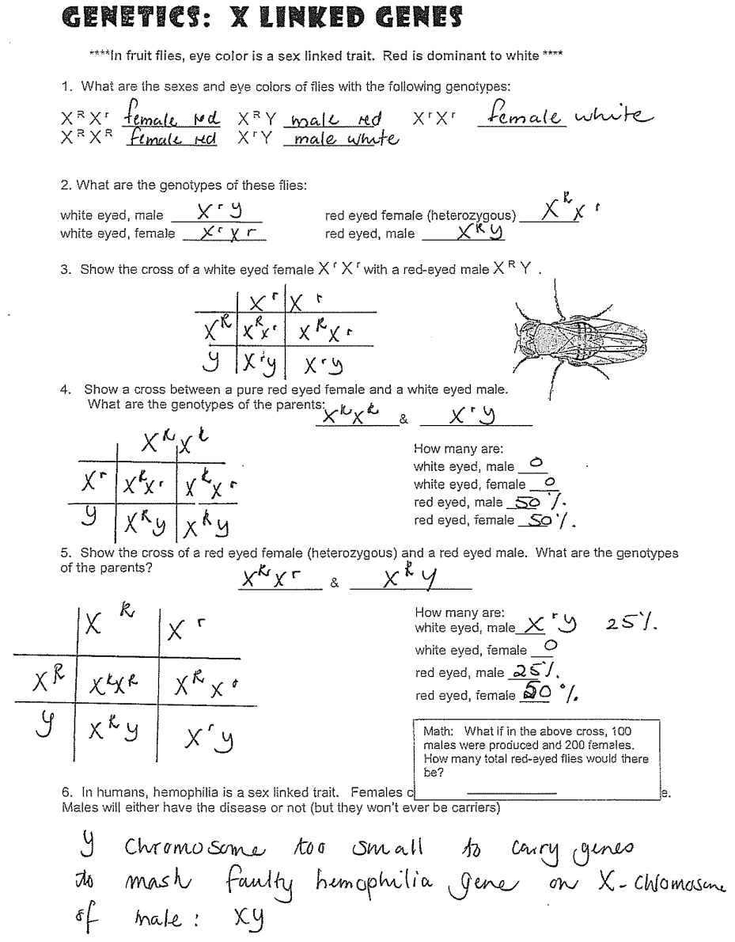

1. What is a mutation?

**Quick sudden change in the DNA code of an organism.**

1. What is a mutagen **This is a substance that can cause a mutation.**

Give examples of mutagens : **UV light, radiation, chemicals**

1. Explain the difference between a mutation and epigenetics.

**In a mutation the DNA code changes,**

**In epigenetics the DNA code does not change, but something in the environment can cause the code to be expressed differently e.g. diet**

1. Define Evolution: **Evolution is the change of the allele frequency of the**

**genepool of a population over a very long time.**

1. Gene: **It is a code for a specific characteristic**

Allele: **It is a different expression of a gene: Eg. for gene Blood type can have 3 alleles: A, B or O**

Chromosome **: Linear collection of genes**

1. Name and explain (five) mechanisms that can contribute towards process of evolution.

**Mutations, natural selection, founder effect, genetic drift, immigration and emigration**

Name and explain **five** mechanisms that can contribute to the process of evolution.

1. **Quick sudden change in the genetic code of DNA, caused by mutagens e.g. UV light**

**Immigration and emigration of new individual of a species will bring or take away alleles from a genepool.**

1. **Founder effect: Group of individuals that separate themselves deliberately form main breeding population and do not interbreed with them. They might not have all the alleles that the main population has and therefore alleles in genepool are restricted.**
2. **Genetic drift: Caused by non- selective factor e.g. major disaster e.g. earthquake wipe out individuals of a population at random and with that certain alleles could be lost that would have enabled them to survive in the aftermath of the disaster. Hence, genetic drift, do not know which alleles will be expressed.**
3. **Natural selection: When a population is put under pressure and something vital changes in their environment e.g. food shortage or predator moves into their community, some individuals will starve or get caught but there could be some that have favorable genes that can enable them to survive or outrun the predator. Therefore “survival of the fittest” and they can transfer favorable alleles to their offspring.**

**Question 31 – 33 Refer to booklet and notes for answers**

